TM and TE Waves Between Parallel Plates
1. Introduction to Electromagnetic Waves
Electromagnetic (EM) waves are solutions to Maxwell’s equations and consist of oscillating electric (E) and magnetic (H) fields propagating through space. Each field component oscillates perpendicular to both the direction of propagation and to each other. EM waves can exist in free space or bounded media, like waveguides. The speed of EM waves in vacuum is c=3×10^8 m/s, and their frequency (f) and wavelength (λ) have the c=fλ. EM waves support multiple polarizations and are the basis for both light (optics) and radio frequency (RF) communication technologies.
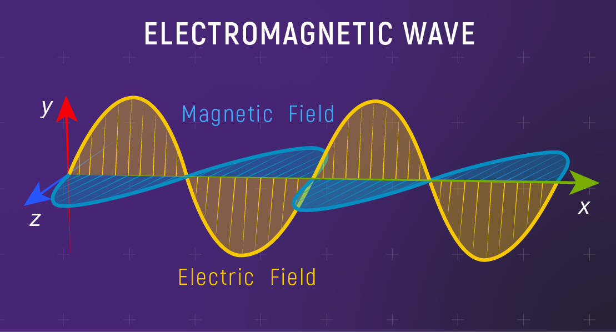

2. Overview of Waveguides
Waveguides are physical structures that confine and guide EM waves from one location to another. Common waveguide geometries are rectangular, circular, and parallel plates. Their walls are typically highly conductive, ensuring minimal energy loss within the guided region. Waveguides operate by allowing certain “modes” that satisfy both Maxwell’s equations and the geometric boundary conditions, enabling signals transmission with high efficiency at microwave and optical frequencies.

3. Types of Electromagnetic Waves: TM vs TE
- TM (Transverse Magnetic):
In TM waves, the magnetic field is entirely transverse to the direction of propagation (Hz=0), while the electric field has a longitudinal component (Ez≠0). TM waves arise from boundary conditions that force the electric field to have a non-zero component in the propagation direction.
- TE (Transverse Electric):
TE waves exhibit an electric field completely transverse (Ez=0), but the magnetic field has a longitudinal component (Hz≠0). Such waves predominate when boundary conditions clamp the electric field to zero along the propagation axis.
Understanding the distinction is crucial when designing waveguide-based systems, as the application often dictates which mode should be excited.
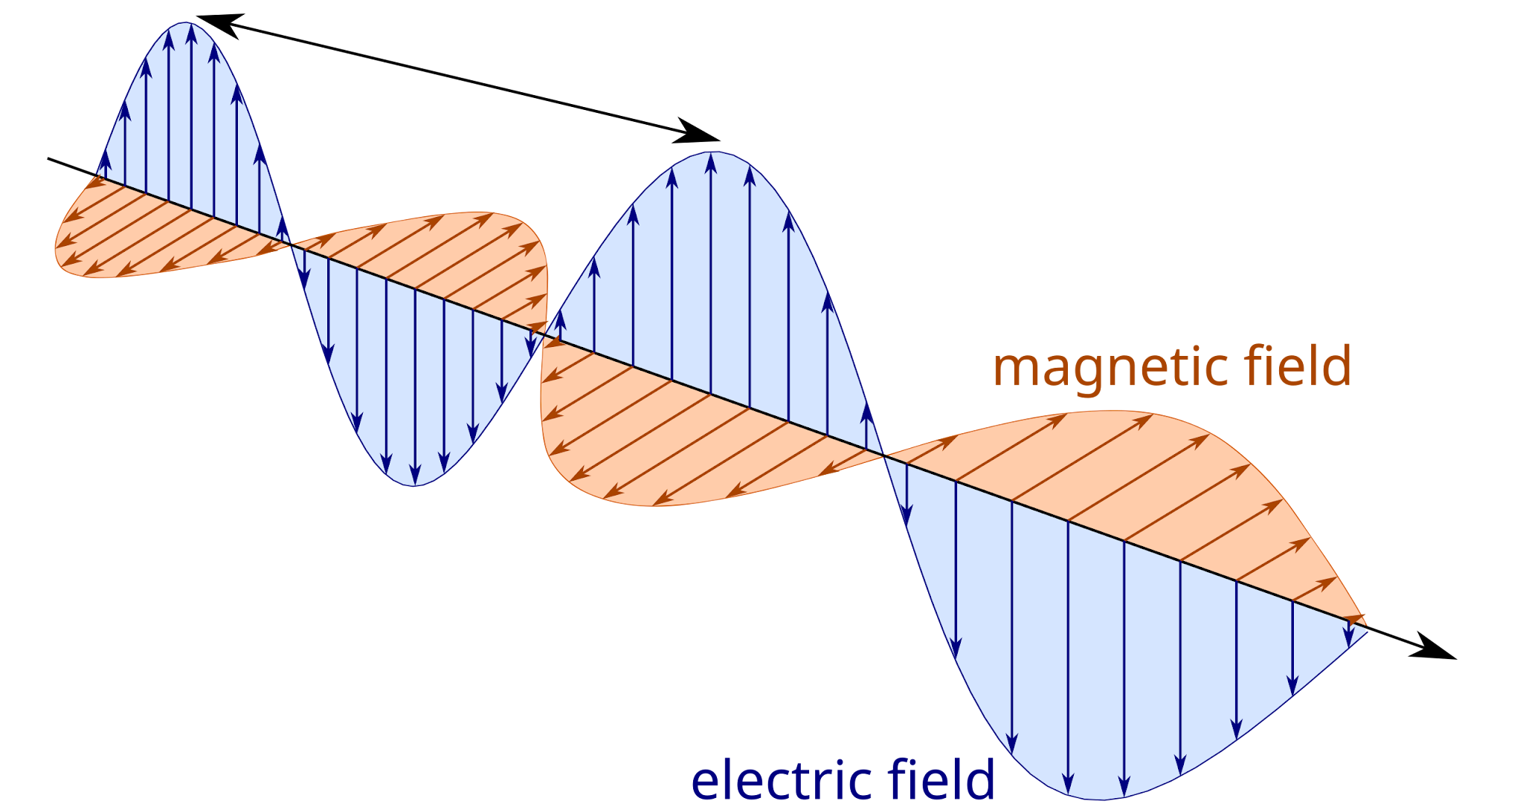

4. Structure of Parallel Plate Waveguides
Parallel plate waveguides consist of two conductors separated by a distance a, extending infinitely along the y- and z-axes. The EM wave propagates along the guide length, with boundary conditions imposed at the conductor surfaces. The configuration supports discrete modes determined by the plate separation and the frequency of operation. Real physical implementations use finite plates; infinite plates serve as idealizations for mathematical simplicity.
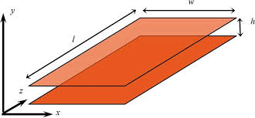

5. Maxwell’s Equations and Boundary Conditions
Maxwell’s equations form the foundation for understanding EM wave behavior within the waveguide:
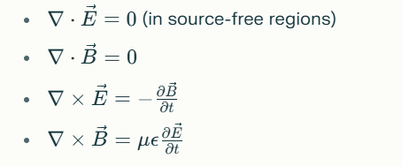
Boundary conditions for parallel plates:
- The tangential component of the electric field at the perfect conductor surface is zero (Et=0).The normal component of the magnetic field at the surface is zero (Bn=0).These restrict the possible field distributions inside the waveguide, leading to mode quantization.

6. Mode Formation in Waveguides
Modes represent the unique field patterns that satisfy the boundary conditions and Maxwell’s equations inside the waveguide. Each mode is denoted by an integer index, corresponding to the number of half-wavelengths fitting between the plates. TE and TM modes have different index conventions. For parallel plate waveguides, only TE and TM are possible—no TEM (Transverse Electromagnetic) mode due to only two conductors. Modes can be visualized as sinusoidal standing waves across the plate separation.

7. Mathematical Representation of TM Waves
TM waves have a non-zero longitudinal electric field (Ez), described mathematically:
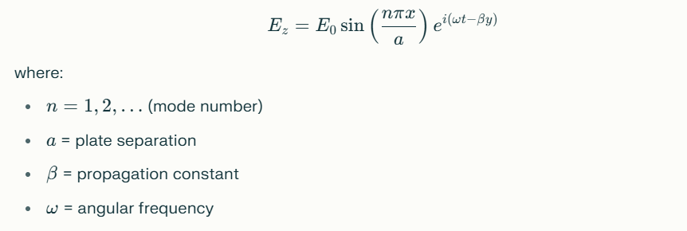
The transverse electric and magnetic components are derived from Ez using Maxwell’s equations, giving:
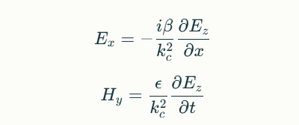

8. Mathematical Representation of TE Waves
TE waves possess a non-zero longitudinal magnetic field (Hz), defined as:


Other field components are computed using Maxwell’s equations:

TE modes begin at n=1, as the n=0 mode does not satisfy boundary conditions.

9. Cutoff Frequencies and Mode Indices
Each mode in a parallel plate waveguide has a cutoff frequency, below which the mode cannot propagate:
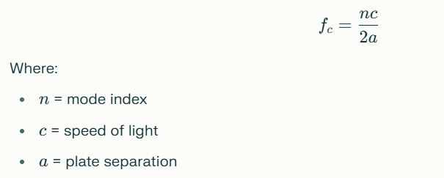
Mode index (n) determines the number of nodes present across the plates and affects the cutoff frequency. Only frequencies above their cutoff propagate with diminishing attenuation; those below become evanescent and decay rapidly.

10. Dispersion Relations
The relationship between phase constant (β) and angular frequency (ω):
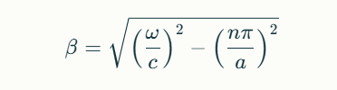
Dispersion describes how β changes with frequency, affecting phase and group velocities:

Dispersive waveguides cause pulse broadening, relevant in optical and RF signal transmission.

11. Field Distributions (Electric and Magnetic)
Field distributions for TE and TM modes are spatial patterns of E and H fields:
- TE1: one half-wavelength maximum between plates, electric field perpendicular to plates, magnetic field parallel.
- TM1: electric field maximum at plate center, vanishing at plates, magnetic field forms closed loops.
Illustrations can be provided showing sinusoidal variation of fields, with nodes and antinodes.

12. Power Transmission and Losses
Power flow through the waveguide is quantified by the time-averaged Poynting vector:

Losses occur due to:
- Conductor losses: finite conductivity plates cause ohmic heating.
- Dielectric losses: imperfect dielectric between plates absorbs energy.
Minimizing losses is vital for high-power and long-distance applications.

13. Practical Applications (Microwave Engineering, Optics)
- Microwave ovens: cavity acts as a resonant waveguide.

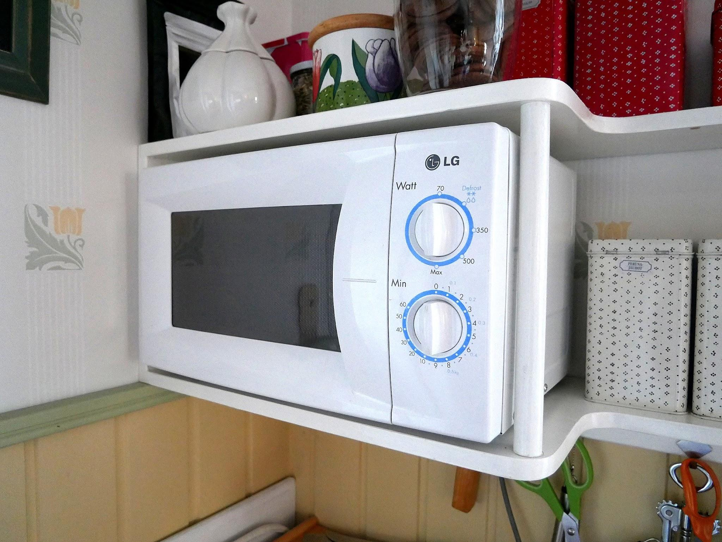

- Radar transmitters: guide microwave energy.

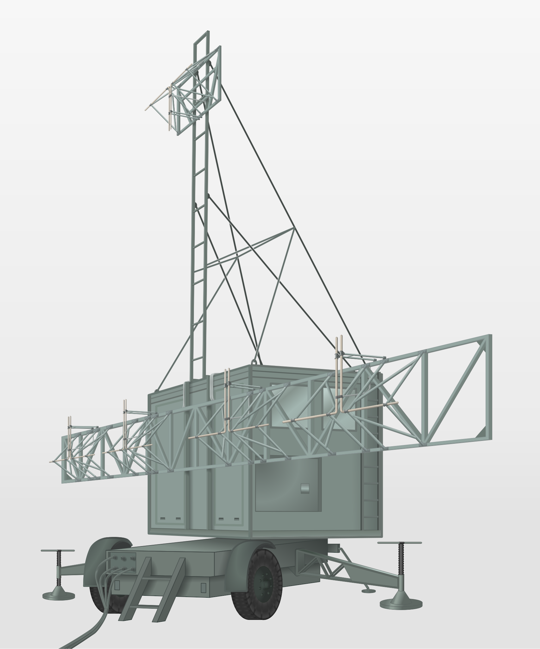

- Optical integrated circuits: parallel-plate geometry for certain modes.
- Filters: select specific frequencies using cut-off properties.
The precise mode behavior allows engineers to optimize system performance.

14. Laboratory Experiments and Observation Techniques
Common experimental setups:
- Use of signal generator and probe to excite waveguide.
- Measurement of cutoff frequencies by varying frequency and observing transmission.
- Mapping electric and magnetic field distributions using voltage and current probes.
- Visualization via oscilloscope or EM field sensors.
These experiments verify theoretical predictions and deepen understanding.

15. Recent Advances & Research Trends
- Metamaterial waveguides for controlling field patterns beyond conventional boundaries.
- Integration with nanoelectronics and photonic chips.
- THz technology for ultra-fast communications.
- Quantum information processing using waveguide modes.
Researchers are continuously improving material properties, miniaturizing waveguide geometry, and exploring new frequency ranges.

